Senarathna G.G.P.C. – 214189E.

Practice Questions.

1. Ramesh’s basic salary is input through the keyboard. His dearness allowance is 40% of  
basic salary, and house rent allowance is 20% of basic salary. Write a program to  
calculate his gross salary.

#include <stdio.h>  
int main() {  
 float b_salary; // this is a basic salary.  
 float g_salary; // this is a gross salary.  
  
 printf("Input the Ramesh’s basic salary,Rs:\n");  
 scanf("%f", &b_salary);  
  
 g_salary = b_salary + (b_salary * 0.40) + (b_salary * 0.20);  
 // calculate dearness allowance and house rent allowance, after that, calculate the gross salary.  
 printf("Ramesh's gross salary is,Rs:%f", g_salary);  
  
 return 0;  
}

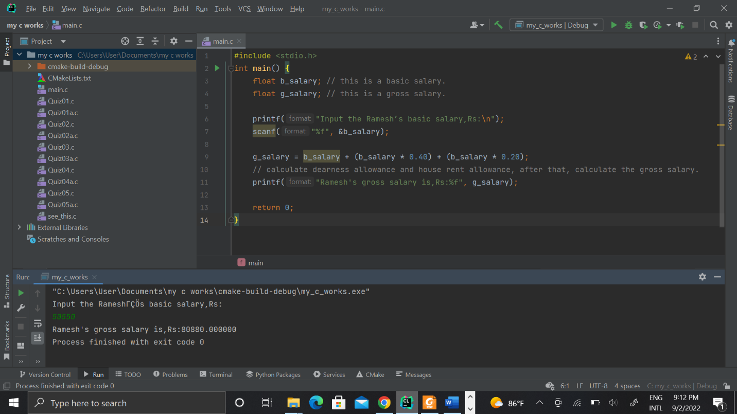

2. The distance between two cities (in km.) is input through the keyboard. Write a program  
to convert and print this distance in meters, feet, inches and centimeters.

#include <stdio.h>  
int main() {  
 float dis; // this a distance between two cities,  
 float M; // distance by meter.  
 float F; // distance by feet.  
 float I; // distance by inches.  
 float C; // distance by centimeter.  
 printf("Input the distance by kilometer between two cities(Km) :\n");  
 scanf("%f", &dis);  
  
 M = dis * 1000; // calculate the distance by meters.  
 printf("Between two cities distance by meters(m) :%f\n", M);  
  
 F = M * 3.28084; // calculate the distance by eeds.  
 printf("Between two cities distance by feeds :%f\n", F);  
  
 I = F * 12; // calculate the distance by inches.  
 printf("Between two cities distance by inches:%f\n", I);  
  
 C = M * 100; // calculate the distance by centimeters.  
 printf("Between two cities distance by centimeter(cm):%f", C);  
 return 0;  
}

3. If the marks obtained by a student in five different subjects are input through the  
keyboard, write a program to find out the aggregate marks and percentage marks  
obtained by the student. Assume that the maximum marks that can be obtained by a  
student in each subject is 100.

#include <stdio.h>  
int main() {  
 float mark1,mark2,mark3,mark4,mark5; // these are marks of different five subjects.  
 float full_mark; // this is full marks in five subjects.  
 float per; // this is percentage of full marks.  
  
 printf("Input the marks of sub1:%f\n");  
 scanf("%f", &mark1);  
 printf("Input the marks of sub2:%f\n");  
 scanf("%f", &mark2);  
 printf("Input the marks of sub3:%f\n");  
 scanf("%f", &mark3);  
 printf("Input the marks of sub4:%f\n");  
 scanf("%f", &mark4);  
 printf("Input the marks of sub5:%f\n");  
 scanf("%f", &mark5);  
  
 if ((mark1 <= 100) && (mark2 <= 100) && (mark3 <= 100) && (mark4 <= 100) && (mark5 <= 100)) {  
 printf("Your marks is valid.\n");  
  
 full_mark = mark1 + mark2 + mark3 + mark4 + mark5; // calculate the full marks.  
 printf("Your full mark:%f\n", full_mark);  
  
 per = full_mark / 5 ; // calculate the percentage.  
 printf("Your percentage is:%f", per);  
 } else {  
 printf("Sorry, your marks is not valid.");  
 }  
 return 0;  
}

4. Temperature of a city in Fahrenheit degrees is input through the keyboard. Write a  
program to convert this temperature into Centigrade degrees.

#include <stdio.h>  
  
int main() {  
 float f_tem; // this is temperature in Fahrenheit degrees.  
 float c_tem; // this is temperature in Centigrade degrees.  
 printf("Input the temperature of a city in Fahrenheit degrees is:\n");  
 scanf("%f", &f_tem);  
  
 c_tem = (f_tem - 32) * 9/5; // calculate and convert this temperature into Centigrade degrees.  
 printf("Temperature of a city in Centigrade degrees is:%f\n", c_tem);  
  
 return 0;  
}

5. The length and breadth of a rectangle and radius of a circle are input through the  
keyboard. Write a program to calculate the area and perimeter of the rectangle, and the  
area and circumference of the circle.

#include <stdio.h>  
int main() {  
 float l1,l2,r; // l1 is e length,l2 is a width and r is a radius.  
 float A1,A2,P1,P2; // A1,P1 are area and perimeter of rectangle.A2,P2 are area and perimeter of circle.  
 printf("Would you like calculate area and perimeter of rectangle and circle,length,width and radius are grater than Zero\n"  
 "OR would you like calculate are and perimeter of rectangle,length and width are grater than Zero,radius is Zero\n"  
 "OR would you like calculate are and perimeter of circle,length and width both are Zero,radius is grater than Zero:\n");  
 scanf("%f,%f,%f", &l1,&l2,&r);  
  
 if ((r > 0) && (l1 > 0) && (l2 > 0)) {  
 printf("You are gonna calculate area and perimeter of rectangle and circle:\n");  
 A1 = l1 * l2;  
 printf("Area of rectangle:%f\n", A1);  
 P1 = (l1 + l2) * 2;  
 printf("Perimeter of rectangle:%f\n", P1);  
 A2 = 3.143 * r * r;  
 printf("Area of circle:%f\n", A2);  
 P2 = 2 * 3.143 * r;  
 printf("Perimeter of circle:%f\n", P2);  
 } else if ((r == 0) && (l1 > 0) && (l2 > 0)) {  
 printf("You are gonna calculate area and perimeter of rectangle:\n");  
 A1 = l1 * l2;  
 printf("Area of rectangle:%f\n", A1);  
 P1 = (l1 + l2) * 2;  
 printf("Perimeter of rectangle:%f\n", P1);  
 } else {  
 printf("You are gonna calculate area and perimeter of circle:\n");  
 A2 = 3.143 * r * r;  
 printf("Area of circle:%f\n", A2);  
 P2 = 2 * 3.143 * r;  
 printf("Perimeter of circle:%f\n", P2);  
 }  
 return 0;  
}

6. Paper of size A0 has dimensions 1189 mm x 841 mm. Each subsequent size A(n) is  
defined as A(n-1) cut in half parallel to its shorter sides. Thus paper of size A1 would  
have dimensions 841 mm x 594 mm. Write a program to calculate and print paper sizes  
A0, A1, A2, … A8.

Part_01;

#include <stdio.h>  
int main() {  
 int a = 1,l1 = 1189,l2 = 841;  
 printf("A0 has dimensions %d mm x %d mm.\n", l1,l2);  
  
 for (a = 1;a <= 8;a++) {  
 if (l1 > l2) {  
 l1 = l1/2;  
 printf("A%d has dimension %d mm x %d mm.\n", a,l1,l2);  
 } else {  
 l2 = l2/2;  
 printf("A%d has dimension %d mm x %d mm.\n", a,l1,l2);  
 }  
 }  
 return 0;  
}

Part_02;

#include <stdio.h>  
  
int main() {  
 int width = 1189,height = 841, temp;  
  
 for(int i = 0;i <= 8;i++) {  
 printf("A%d : %d mm x %d mm\n", i,width,height);  
 temp = width;  
 width = height;  
 height = temp/2;  
 }  
 return 0;  
}

